EXPT NO: 9 | TEXT CLASSIFICATION AND TEXT GENERATION USING TRANSFORMERS
DATE: | TEXT CLASSIFICATION AND TEXT GENERATION USING TRANSFORMERS

PRE-LAB QUESTIONS (PROVIDE BRIEF ANSWERS TO THE FOLLOWING QUESTIONS)
1. What is a Transformer model in Natural Language Processing (NLP)?
A Transformer is a deep learning model used to process natural language.
It uses a mechanism called self-attention to understand words and their relationships.
It is widely used in translation, text classification and text generation.
2. What is BERT, and how is it used for text classification?
BERT stands for Bidirectional Encoder Representations from Transformers.
It understands the context of words by reading text in both directions.
It is used to classify text into categories such as positive, negative or neutral.
3. What is fine-tuning in the context of pretrained language models?
Fine-tuning is the process of training a pretrained model on a specific dataset.
It helps the model learn a particular task.
It improves the model's performance for that task.
4. What is the difference between text classification and text generation?
Text classification assigns a category or label to the given text.
Text generation creates new text based on the given input.
Example: Classification identifies positive reviews, while generation creates sentences.
5. What is a sequence-to-sequence model, and how is it used in text generation?
A sequence-to-sequence model converts an input sequence into an output sequence.
It uses an encoder to understand the input and a decoder to generate the output.
It is used in machine translation, text summarization and chatbot applications.
AIM
To implement text classification by fine-tuning a pretrained BERT model and develop a simple sequence-to-sequence text generation application using Transformer models.

SOFTWARE REQUIREMENTS
- Python
- Google Colab
- Hugging Face Transformers
- Hugging Face Datasets
- PyTorch
- NumPy
- Pandas
- Matplotlib

OBJECTIVES
Students will be able to:
- Understand the architecture and working of Transformer models in NLP.
- Understand the concepts of text classification and text generation.
- Load and preprocess text datasets for NLP applications.
- Fine-tune a pretrained BERT model for text classification.
- Evaluate the classification model using appropriate performance metrics.
- Implement a sequence-to-sequence application using a pretrained Transformer model.
- Generate text using the model's text generation capabilities.
- Analyze and compare the outputs produced by the Transformer models.

PROCEDURE
PART A: DATASET PREPARATION AND TEXT PREPROCESSING
Perform the following tasks:
- Load a text dataset such as the IMDb movie review dataset.
- Explore the dataset and examine sample text entries and their labels.
- Check the number of samples and the distribution of class labels.
- Separate the dataset into training and testing sets or use the predefined splits.
- Load a pretrained tokenizer corresponding to the BERT model.
- Tokenize the text using the tokenizer.
- Apply padding and truncation to maintain consistent input lengths.
- Convert the tokenized data into the required format for model training.
- Prepare the dataset for batch-wise processing.

CODE:
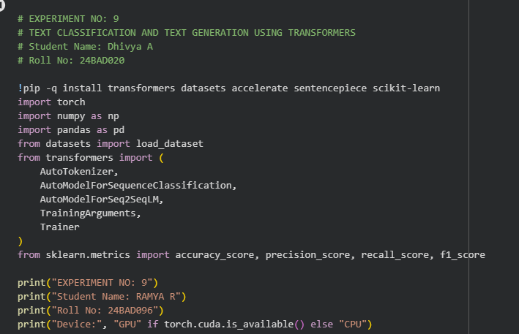
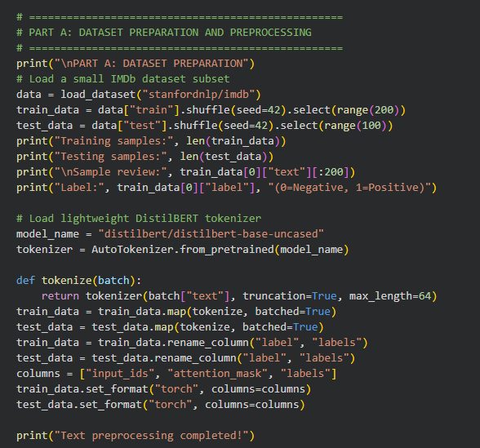
OUTPUT:
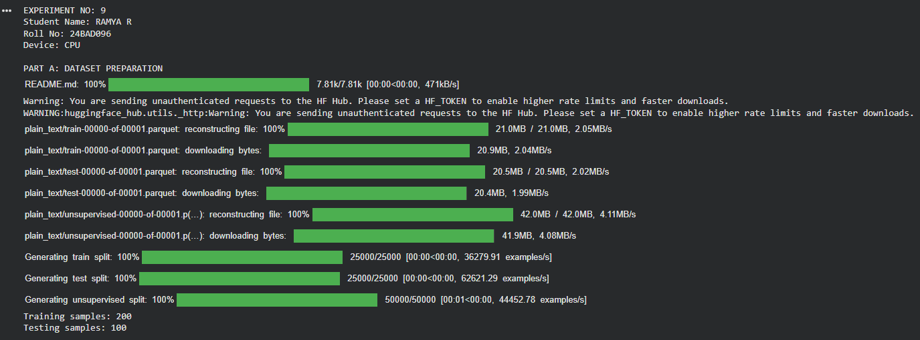
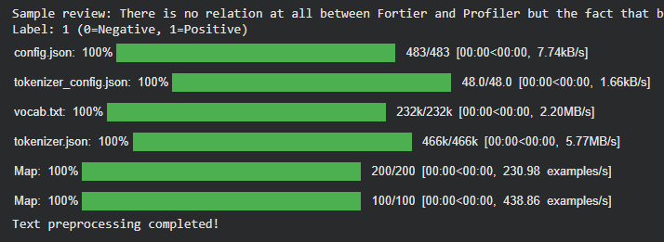

PART B: FINE-TUNING BERT FOR TEXT CLASSIFICATION
Perform the following tasks:
- Load a pretrained BERT model for sequence classification.
- Configure the model for the required number of classes.
- Prepare the tokenized training and testing datasets.
- Define the training parameters, including learning rate, batch size, and number of epochs.
- Fine-tune the BERT model using the training dataset.
- Evaluate the trained model using the testing dataset.
- Calculate appropriate performance metrics, such as accuracy, precision, recall, and F1-score.
- Test the model using new text inputs.
- Display the predicted class labels and corresponding evaluation results.
- Save the fine-tuned model and tokenizer.

CODE:
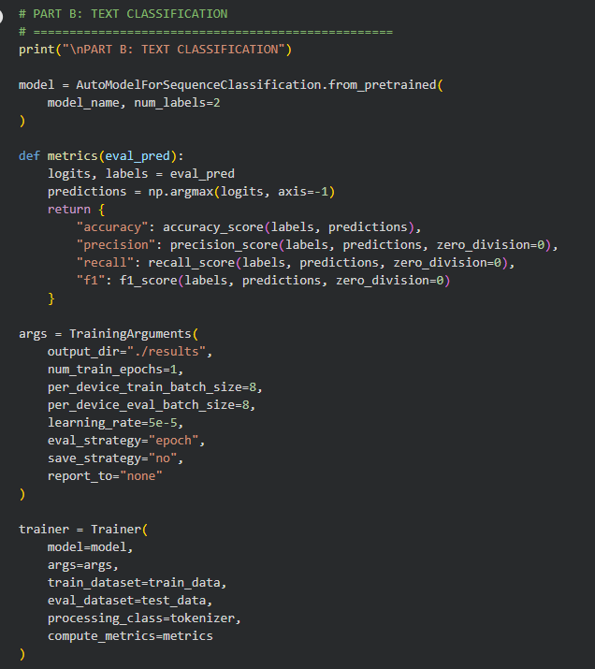
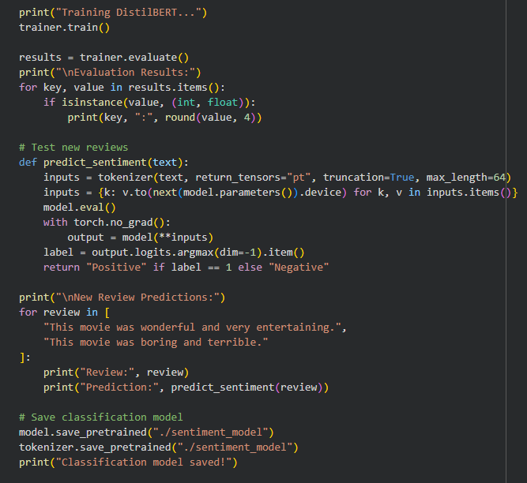
OUTPUT:
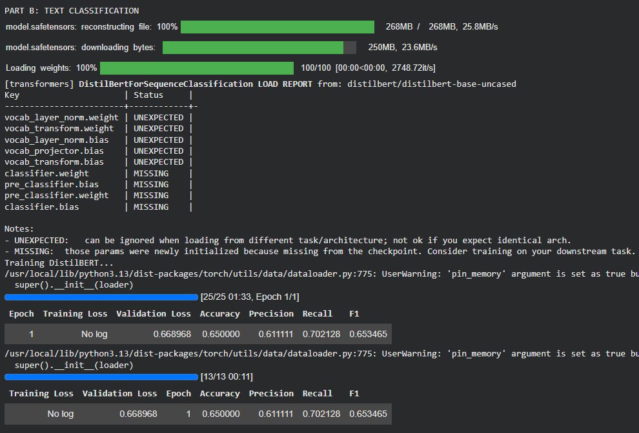
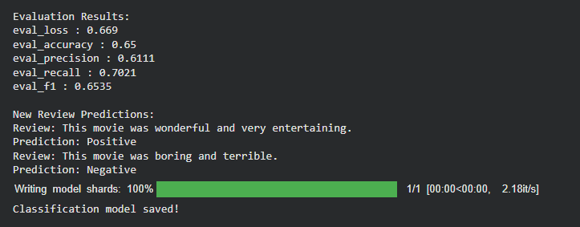
PART C: IMPLEMENTING A SEQUENCE-TO-SEQUENCE APPLICATION USING TRANSFORMERS
Perform the following tasks:
- Load a pretrained sequence-to-sequence Transformer model, such as T5-small.
- Load the corresponding tokenizer.
- Prepare a sample text input for the selected text generation task.
- Preprocess the input according to the model's requirements.
- Generate output text using the pretrained model.
- Apply appropriate generation parameters, such as maximum output length and beam search, where applicable.
- Display the input text and the generated output.
- Experiment with different input texts and generation settings.
- Observe how changes in the input and generation parameters affect the output.
- Save the generated outputs for further analysis.

CODE:
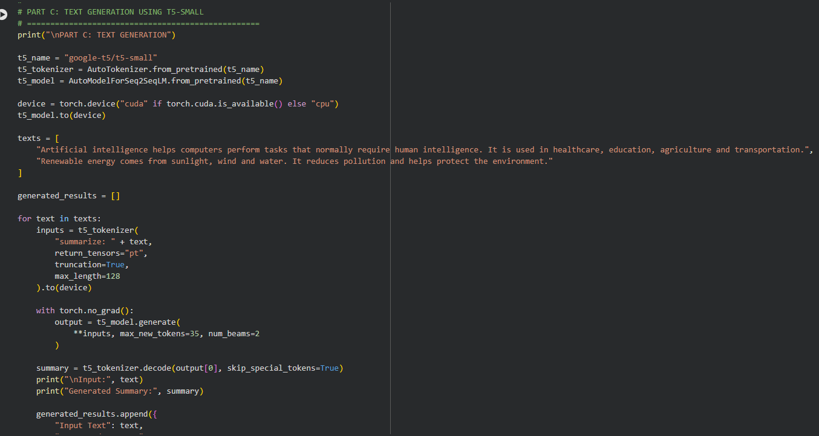
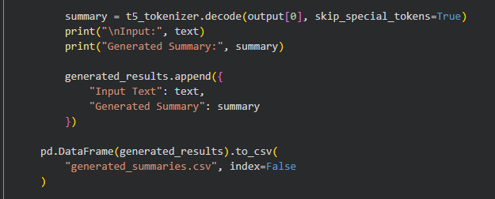

OUTPUT:
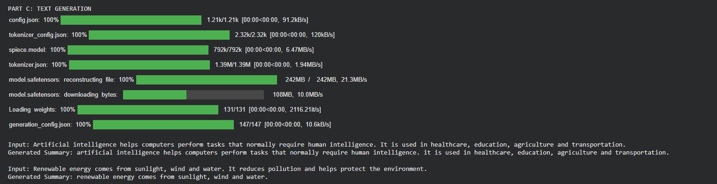
PART D: MODEL TESTING AND OUTPUT ANALYSIS
Perform the following tasks:
- Test the fine-tuned BERT model using sample positive and negative text inputs.
- Record the predicted class labels for the test inputs.
- Analyze the classification results using the selected evaluation metrics.
- Test the sequence-to-sequence model using different input texts.
- Compare the generated outputs for different inputs and generation settings.
- Examine the relevance, readability, and coherence of the generated text.
- Identify possible errors or limitations in the classification and generation outputs.
- Compare the applications of BERT-based classification and sequence-to-sequence text generation.
- Summarize the observations obtained from both models.

CODE:
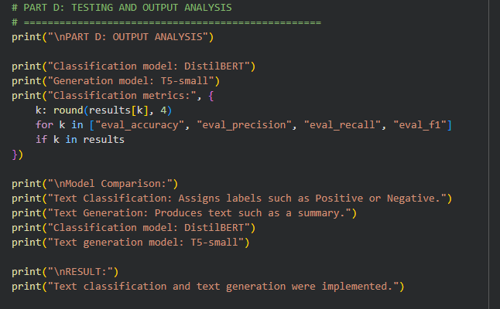
OUTPUT:
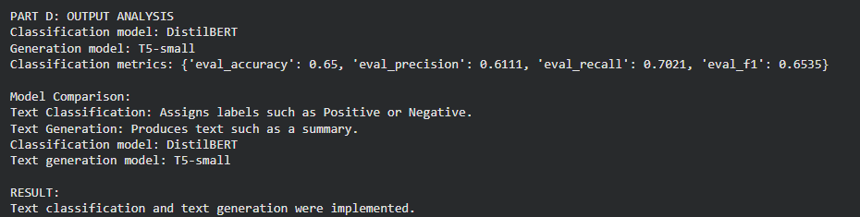
EXPECTED OUTCOME
Students will understand the architecture and applications of Transformer models in Natural Language Processing. They will learn to fine-tune a pretrained BERT model for text classification, preprocess textual data, and evaluate classification performance using appropriate metrics. Students will also develop a simple sequence-to-sequence text generation application using a pretrained Transformer model and analyze the quality and relevance of the generated outputs.

POST-LAB QUESTIONS (PROVIDE BRIEF ANSWERS TO THE FOLLOWING QUESTIONS)
1. What is the role of BERT in text classification?
- BERT understands the context of words in a sentence.
- It analyzes the meaning of the given text.
- It classifies the text into categories like positive or negative.
2. Why is tokenization required before providing text to a Transformer model?
- Tokenization splits text into smaller units called tokens.
- It converts tokens into numerical IDs.
- These IDs help the Transformer understand the text.

3. What is the purpose of fine-tuning a pretrained BERT model?
- Fine-tuning adapts BERT to a specific task.
- It trains the model using a task-specific dataset.
- It improves the model's performance.
4. Mention any two evaluation metrics used for text classification.
- Accuracy measures the number of correct predictions.
- Precision measures how many positive predictions are correct.
- These metrics help evaluate model performance.
5. What is the role of the encoder and decoder in a sequence-to-sequence Transformer?
- The encoder understands and processes the input text.
- The decoder generates the output sequence.
- Both work together to convert input into output.
6. What is the difference between text classification and text generation?
- Text classification assigns a category to given text.
- Text generation creates new text based on the input.
- Example: sentiment detection and sentence generation.
7. How does the maximum output length affect text generation?
- Maximum output length controls the number of generated tokens.
- A smaller limit produces shorter text.
- A larger limit allows longer text generation.
8. Mention one real-world application of Transformer-based text classification and one application of text generation.
- Text classification is used for spam email detection.
- Text generation is used for chatbot responses.
- Both are widely used in natural language processing.

SUGGESTIONS FOR DATASETS & MODELS
Datasets:
- IMDb Movie Reviews – https://huggingface.co/datasets/stanfordnlp/imdb
- GLUE Benchmark – https://huggingface.co/datasets/nyu-mll/glue
- SST-2 Sentiment Classification – https://huggingface.co/datasets/nyu-mll/glue

Pretrained Models:
- BERT Base Uncased – https://huggingface.co/google-bert/bert-base-uncased
- T5-small – https://huggingface.co/google-t5/t5-small

ASSESSMENT
Description | Max Marks | Marks Awarded
Pre Lab Exercise | 5
In Lab Exercise | 10
Post Lab Exercise | 5
Viva | 10
Total | 30
Faculty Signature

